Mark Pemberton
12/13/2025
Project Two Read Me
CS 340

Project Overview
This project involved the design and development of an interactive web-based dashboard for Grazioso Salvare, an organization that specializes in training rescue animals. The dashboard provides an interface for interacting with animal shelter data obtained from the Austin Animal Center Outcomes dataset. The goal of the application is to assist Grazioso Salvare in identifying dogs that are suitable candidates for various types of search-and-rescue training.
The application integrates a MongoDB database with a Python-based dashboard using the Dash framework. Users can filter animals by rescue type, view the filtered results in a dynamic data table, visualize geographic data on a map, and analyze breed distributions through an interactive chart.

Required Functionality
The completed dashboard meets all functional requirements defined in the project specifications.
The application includes interactive filtering options that allow users to select one of the following rescue categories: Water Rescue, Mountain or Wilderness Rescue, Disaster or Individual Tracking, and Reset. Selecting a rescue type dynamically updates all dashboard components.
The dashboard displays a data table that responds in real time to the selected filters. The table supports sorting, pagination, and column-based filtering to improve usability.
Two charts are included in the dashboard. A pie chart displays the distribution of dog breeds within the current filtered dataset. A geolocation map displays the location of animals selected from the data table.
Branding requirements were met by including the Grazioso Salvare logo and a unique identifier containing the developer’s name within the dashboard layout.

Dashboard Screenshots
The following screenshots document the functionality of the dashboard and demonstrate successful testing and deployment.
Dashboard at startup showing unfiltered data
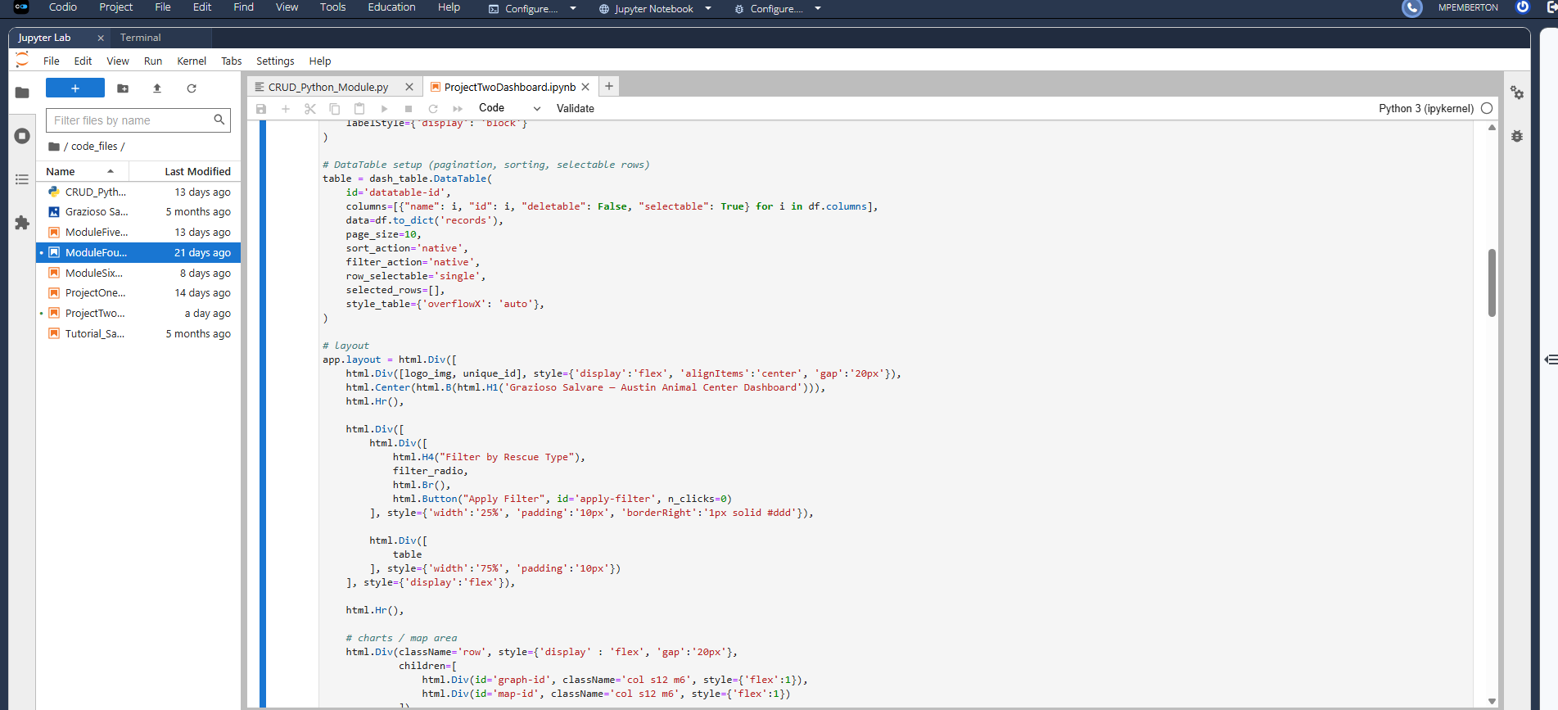
Water Rescue filter applied
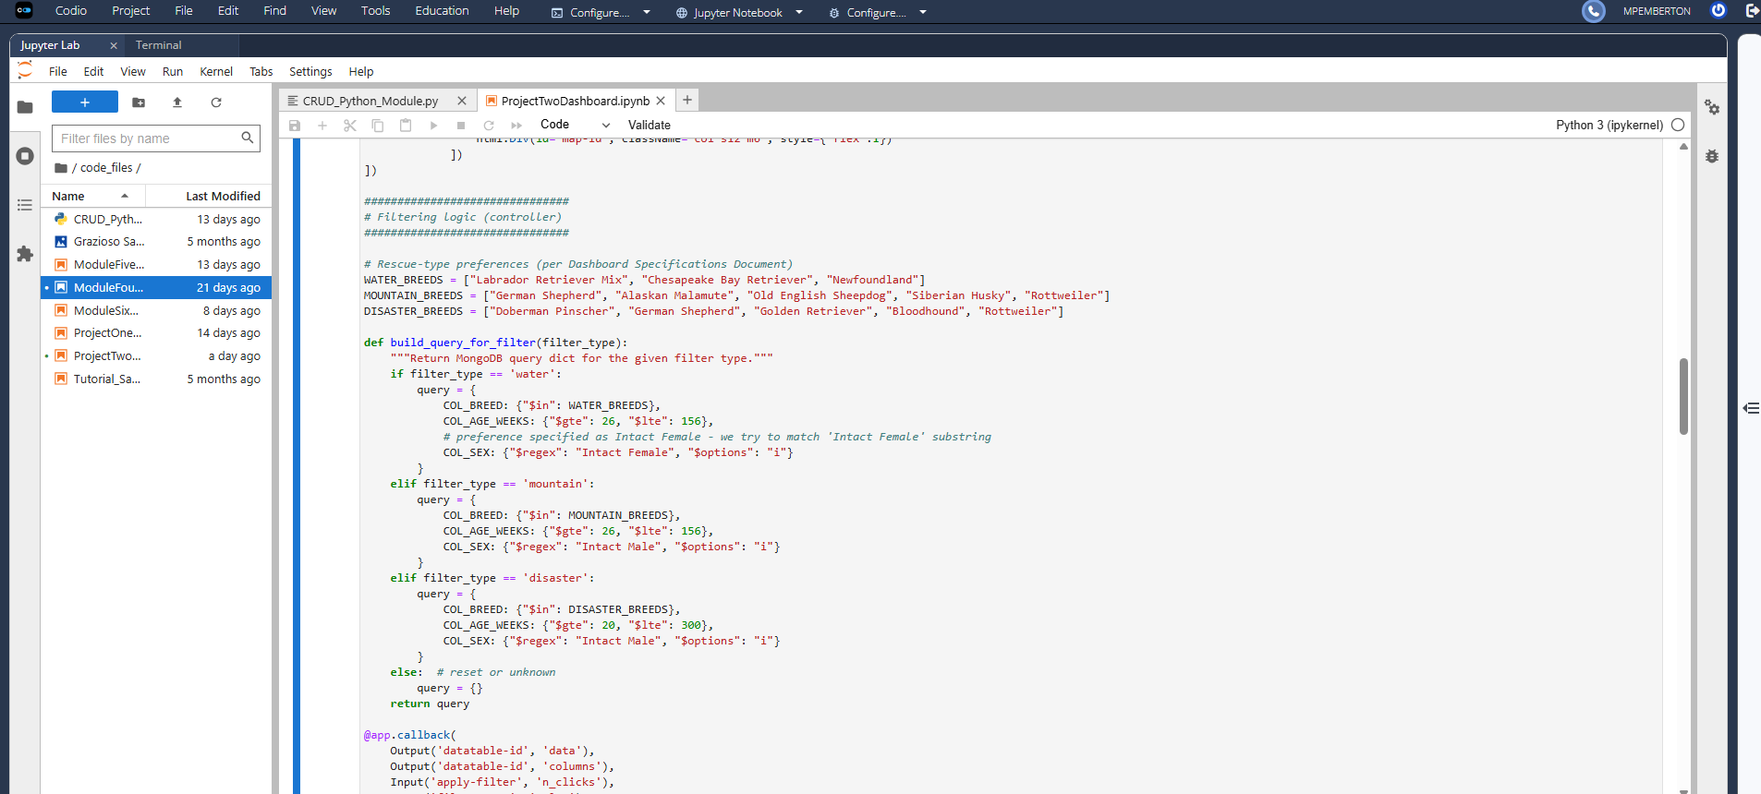
Mountain or Wilderness Rescue filter applied
Disaster or Individual Tracking filter applied
Reset filter applied returning all data
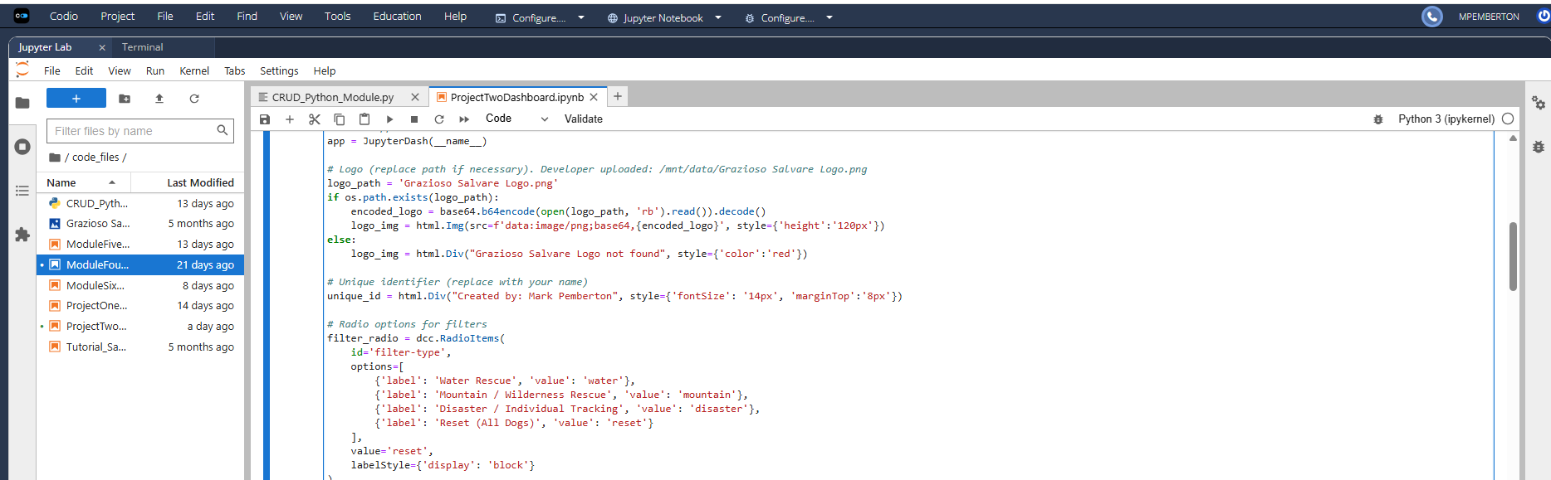
Table with logo
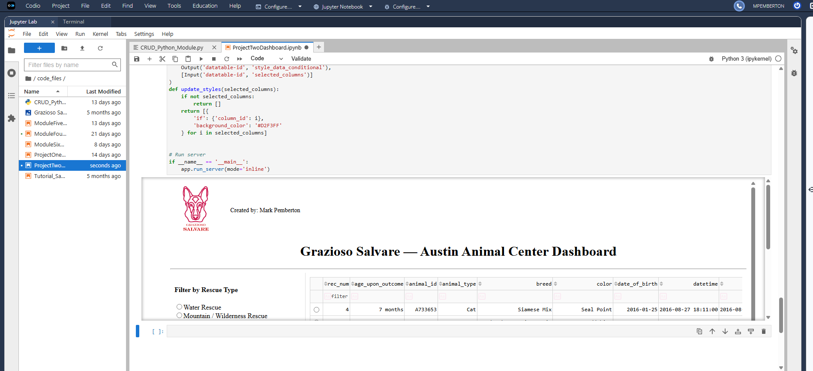

Tools and Technologies Used
MongoDB was used as the database management system for this project. It was selected due to its flexible document-based data model, which is well suited for handling semi-structured data such as animal shelter records. MongoDB integrates efficiently with Python through the PyMongo library, enabling straightforward implementation of CRUD operations.
The Dash framework was used to implement both the view and control components of the application. Dash allows the creation of interactive web applications using Python without requiring separate frontend technologies. Dash callbacks enable communication between user interface elements and the database, allowing for dynamic updates across the dashboard.
Additional Python libraries used in this project include pandas for data manipulation, Plotly Express for chart creation, Dash Leaflet for geolocation mapping, NumPy for data handling, and base64 for image encoding.

Project Development Process
The project began with a review of the project requirements and the Dashboard Specifications Document. The MongoDB database and CRUD Python module developed in Project One were reused and integrated into the dashboard.
An initial unfiltered data table was created to display all animal records from the database. Interactive filtering options were then implemented using Dash radio buttons. MongoDB queries were developed for each rescue category using the preferred breed, age, and sex criteria provided by the client.
Dash callbacks were created to ensure that the data table, pie chart, and geolocation map updated dynamically based on user input. Branding elements were added to the dashboard, and the application was tested thoroughly to confirm that each filter and widget functioned as expected.
Screenshots were captured to document the working state of the dashboard and to serve as proof of functionality.

Challenges and Solutions
One challenge encountered during development was constructing accurate MongoDB queries due to inconsistencies in data formatting within the dataset. This issue was addressed by using regular expressions and range-based queries to match the required criteria reliably.
Another challenge involved the presence of MongoDB ObjectID fields, which caused errors in the Dash DataTable component. This problem was resolved by removing the internal _id field from the dataset before rendering the table.
Additional challenges included handling missing geolocation data and resolving indentation errors caused by mixed tabs and spaces in Jupyter Notebook cells. These issues were resolved by adding conditional checks and enforcing consistent indentation using spaces.

Instructions for Reproducing the Project
To reproduce this project, Python 3.x and MongoDB must be installed on the system. The required Python libraries include dash, dash-leaflet, plotly, pandas, numpy, and pymongo.
The user should clone the project repository and ensure that the MongoDB database is running and populated with the Austin Animal Center Outcomes dataset. The CRUD Python module must be in the same directory as the dashboard notebook. The dashboard can then be launched by running the ProjectTwoDashboard.ipynb file in JupyterLab or Jupyter Notebook.

References
Austin Animal Center Outcomes Dataset. (n.d.). Retrieved from https://data.austintexas.gov/Animals/Austin-Animal-Center-Outcomes/9t4d-g238
Plotly Dash Documentation. (n.d.). Retrieved from https://dash.plotly.com
MongoDB Documentation. (n.d.). Retrieved from https://www.mongodb.com/docs

